**LaRose Wellness Retreat**

is officially open for Sledding Parties for the winter season.

Winter Sledding

Parties

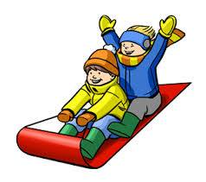

2 hours for $40.

4 hours for $80.

Use of kitchen facilities, hot chocolate and campfire is available.

Contact Cheryl LaRose:906-353-6714