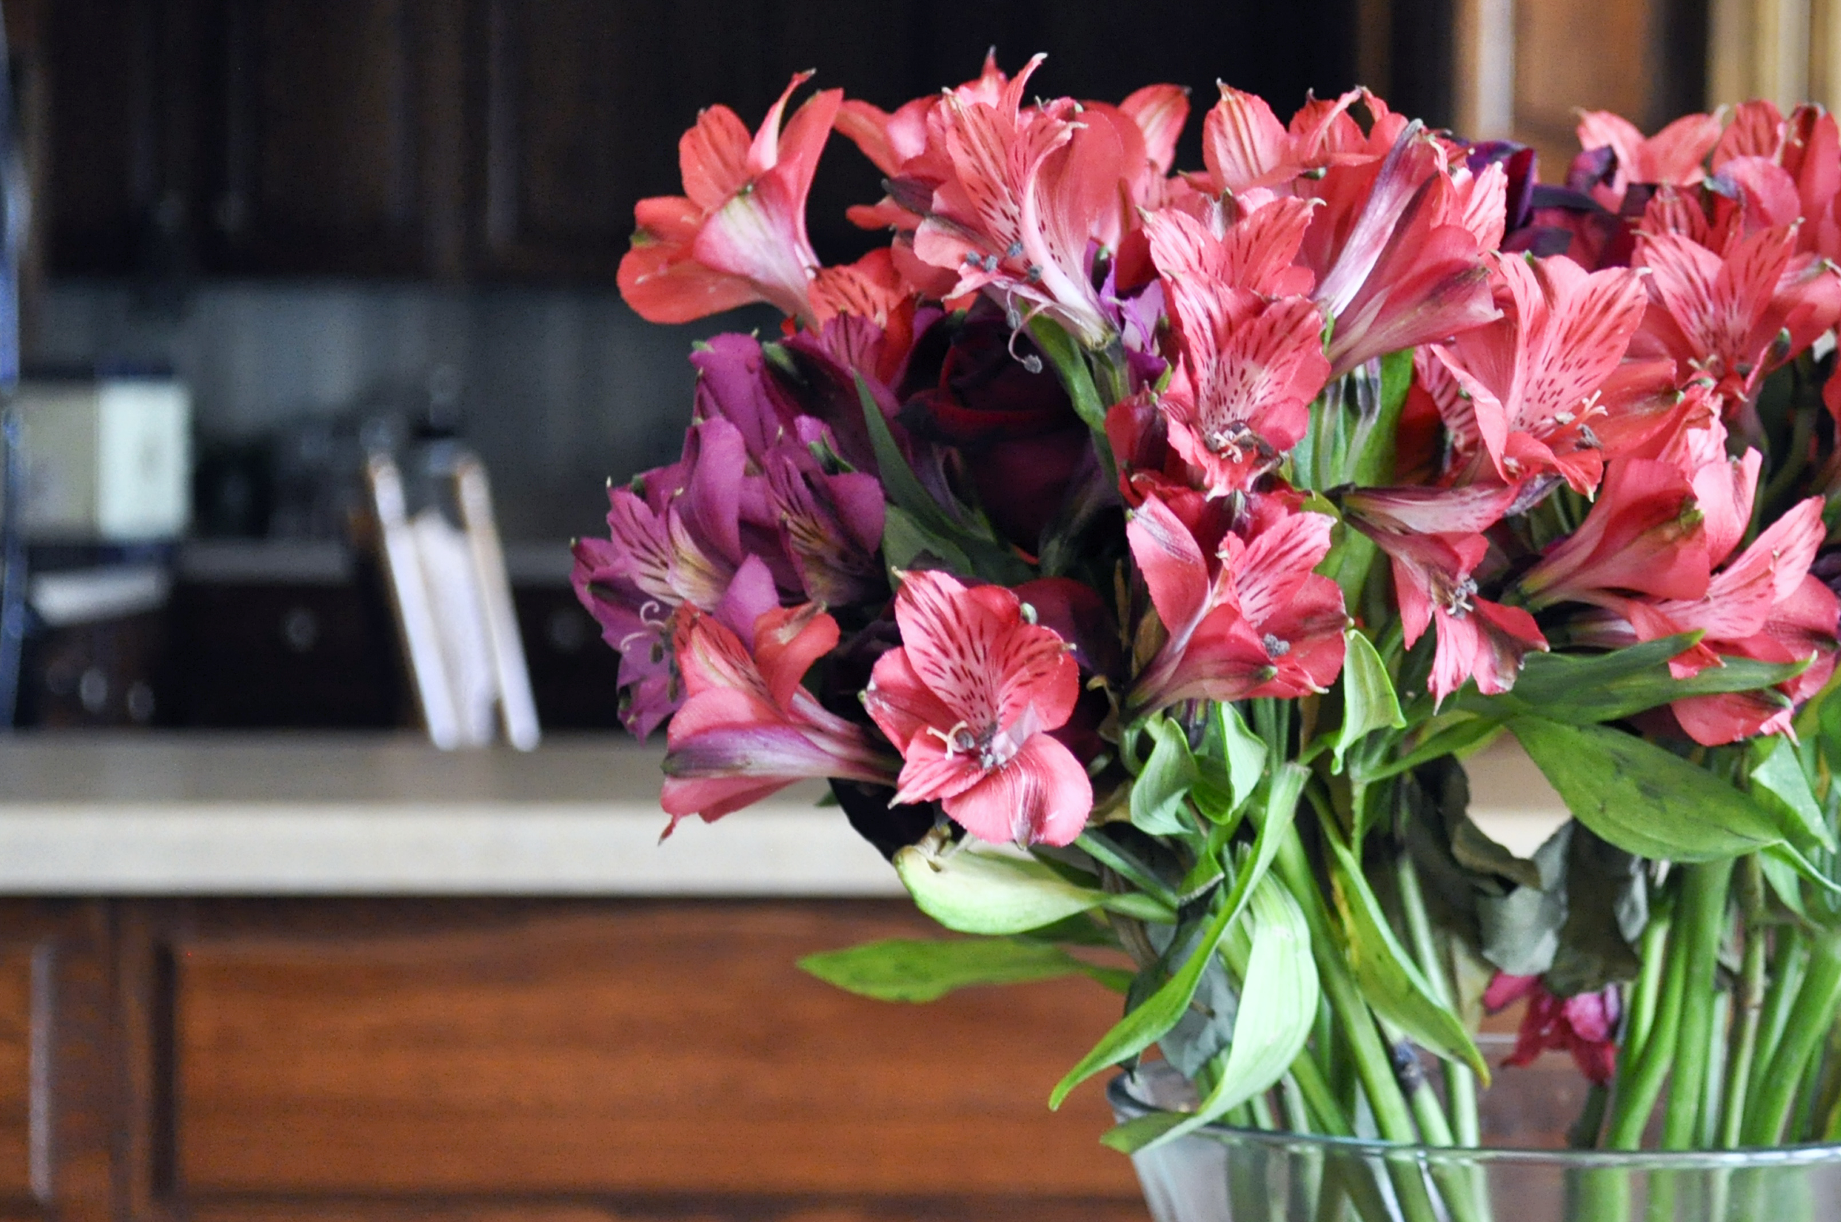
  - Mother’s Day Retreat
  - Grandmother’s, Mother’s, Daughters, and Girlfriends Welcome
Saturday, May 9th 4pm thru Sunday, May 10th 11am
Includes: Rooms for the Evening, Pampering, Activities, Meals and Snacks

LaRose Wellness Retreat
If interested and more information call 906-353-6714
4 rooms available-double occupancy: $110. | 1 room suite available | 4 people $280

