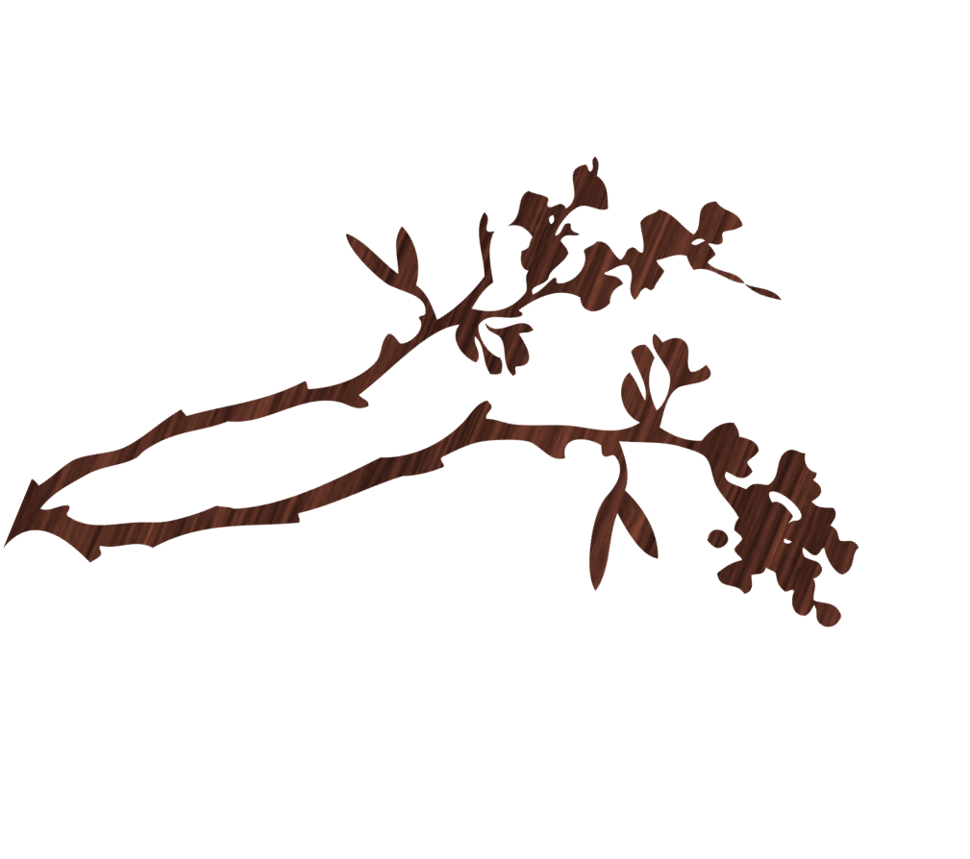
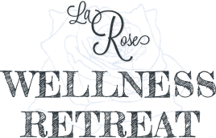
Water AerobicS
for more information contact: Cheryl Larose @ 906-353-6714
Water Fitness classes (13 YEARS & OLDER)
In Keweenaw Bay
Summer Session : July14-August 6
When: Tuesdays and Thursdays (4 weeks)
Times: 9:45am-11:00am, 11:00am-12:15pm,12:15-1:30pm, 4-5:15pm, 5:45-7:00pm

Join certified water aerobics instructor Kristina waara for water fitness classes in a heated Pool.

Cost: $70.00 for 4 Week Session
Hot Tub and Sauna options included in price
Private group sessions available
Senior Citizen group sessions available

